ISO 20022

Transparency of Holdings

Message Definition Report Part 1

Maintenance 2016/2017 - Approved by ISO 20022 Securities SEG on 1 February 2017

This document provides information about the use of the messages for the Securities Balance Transparency Report and includes, for example, business transactions and examples.

July 2017

Table of Contents

Table of Contents 2

1 Introduction 3

1.1 Terms and Definitions 3

1.2 Abbreviations and Acronyms 3

1.3 Document Scope and Objectives 4

1.4 References 4

2 Scope and Functionality 5

2.1 Background 5

2.2 Scope 5

2.3 Groups of MessageDefinitions and Functionality 6

3 BusinessRoles and Participants 7

3.1 Participants and BusinessRoles Definitions 7

3.2 BusinessRoles and Participants Table 8

4 BusinessProcess Description 10

5 Description of BusinessActivities 11

5.1 Holdings Reporting 11

6 BusinessTransactions 13

6.1 Transparency of Holdings Reporting 13

7 Business Examples 14

7.1 Transparency Of Holdings Reporting 14

Revision Record 52

Preliminary Note

The Message Definition Report (MDR) is made of three parts:

MDR part 1

This describes the contextual background required to understand the functionality of the proposed message set. Part 1 is produced by the submitting organisation that developed or maintained the message set in line with an MDR Part 1 template provided by the ISO 20022 Registration Authority (RA) on [www.iso20022.org](http://www.iso20022.org/).

MDR part 2

This is the detailed description of each message definition of the message set. Part 2 is produced by the RA using the model developed by the submitting organisation.

MDR part 3

This is an extract if the ISO 20022 Business Model describing the business concepts used in the message set. Part 3 is an Excel document produced by the RA.

# Introduction

## Terms and Definitions

The following terms are reserved words defined in ISO 20022 Edition 2013 – Part1. When used in this document, the UpperCamelCase notation is followed.

|  |  |
| --- | --- |
| Term | Definition |
| BusinessRole | Functional role played by a business actor in a particular BusinessProcess or BusinessTransaction. |
| Participant | Involvement of a BusinessRole in a BusinessTransaction. |
| BusinessProcess | Definition of the business activities undertaken by BusinessRoles within a BusinessArea whereby each BusinessProcess fulfils one type of business activity and whereby a BusinessProcess may include and extend other BusinessProcesses. |
| BusinessTransaction | Particular solution that meets the communication requirements and the interaction requirements of a particular BusinessProcess and BusinessArea. |
| MessageDefinition | Formal description of the structure of a message instance. |

1. When a MessageDefinition or message identifier is specified, it should include the variant and version number. However, in this document (except in the business examples section, if present), variant and version numbers are not included. In order to know the correct variant and version number for a MessageDefinition, the related Message Definition Report Part 2 document should be consulted.

## Abbreviations and Acronyms

The following is a list of abbreviations and acronyms used in the document.

|  |  |
| --- | --- |
| Abbreviation/Acronyms | Definition |
| ACK | Acknowledgement |
| AML | Anti-Money Laundering |
| BIC | Business Identifier Code |
| CSD | Central Securities Depository |
| CUG | Closed User Group |
| IBAN | International Bank Account Number |
| ICSD | International Central Securities Depository |
| KYC | Know Your Customer |
| MCR | Message Change Request |
| MDR | Message Definition Report |
| NAK | Negative acknowledge (reject) |
| OAGi | Open Application Group |
| SEG | Standards Evaluation Group |
| SLA | Service Level Agreement |
| SMPG | Securities Market Practice Group (www.smpg.info) |
| XML | eXtensible Mark-up Language |

## Document Scope and Objectives

This document is the first part of the Message Definition Report (MDR) that describes the BusinessTransactions and underlying message set. For the sake of completeness, the document may also describe BusinessActivities that are not in the scope of the business processes covered in this document.

This document describes the following:

* the BusinessProcess scope
* the BusinessRoles involved in these BusinessProcesses

The main objectives of this document are as follows:

* to provide information about the messages that support the business processes
* to explain the BusinessProcesses and BusinessActivities these messages have addressed
* to give a high level description of BusinessProcesses and the associated BusinessRoles
* to document the BusinessTransactions
* to provide business examples

The messages definitions are specified in Message Definition Report Part 2.

## References

|  |  |  |  |
| --- | --- | --- | --- |
| Document | Version | Date | Author |
| ISO 20022 Business Justification – Tansparency of Holdings (BJ 79) |  | 2013-12-31 | Clearstream |
| ISO 20022 Investment Funds/Transparency of Holdings Maintenance Change Request 2016/2017 |  | 2016-11-10 | Clearstream |

# Scope and Functionality

## Background

This Message Definition Report covers a set of two ISO 20022 MessageDefinitions developed by Clearstream Banking S.A. and Clearstream International S.A., and initially approved by the Securities Standards Evaluation Group (SEG) on 29 March 2016. These MessageDefinitions are specifically designed to support shareholder transparency of holdings.

The detailed description of each MessageDefinitionis provided in Message Definition Report Part 2.

In the 2016-2017 maintenance cycle, one message has been updated. The updated message is:

|  |  |  |
| --- | --- | --- |
|  | MessageDefinition | Message Identifier |
|  | Securities Balance Transparency Report | semt.041.001.02 |

## Scope

As described in the ISO 20022 Business Justification, this set of Transparency of Holdings messages covers the reporting of holdings information. These statements of holdings are sent “downstream” in the custody chain, from a customer to its custodian, where the statements can be enriched with the custodian’s own data, compiled with other inbound statements, split by place of safekeeping (or other grouping of financial instruments), and forwarded to the next designated “downstream” custodian. Ultimately, the reports arrive at the relevant “issuers”, for example, fund companies and transfer agents. The enriched statements may also report on a given customer account, and be sent “upstream” in the custody chain, like a regular custody statement of holdings but with additional levels of account structures and the same customer data as is reported to the fund company/transfer agent.

The same message is used for both directions of reporting, and regardless of the level in the account structure, that is, the concentrations of holdings that are being reported.

This message set is primarily intended for holdings of shares in investment funds, but other domains are not excluded and may be covered.

Funds Hub

Fund Distributor

Fund of Funds

Universal Bank

Custodian Bank

(I)CSD

Transfer  
Agent

Transfer  
Agent

Fund  
Accountant

1

1

2

2

3

3

3

4

1

4

Figure 1, a chain of custodians

1. Investor-side companies use accounts in banks for the safekeeping of investment funds. If a company in the distribution chain has multiple commercial agreements with a fund company, it uses the transparency of holdings statement to provide the bank with a break-down of the holdings.
2. Banks use nominee accounts in a CSD or ICSD for the safekeeping of investment funds. The transparency of holdings statement is used where a bank wishes to provide the (I)CSD with a break-down of assets held in the omnibus account.
3. The CSD and ICSD use nominee omnibus accounts in the respective registers of shareholders. The transparency of holdings statement provides the respective fund companies with break-downs of holdings of the (I)CSD customers as well as customers of the (I)CSD customers.
4. The (I)CSD and its customers may also use the transparency of holdings statement to provide its respective customers with a statement in return, enriched with the same details that have been sent ”downstream”.
5. A recipient of a transparency of holdings statement may respond with a status message, to accept or reject (partial or whole) an inbound statement. This is not shown in the diagram.

## Groups of MessageDefinitions and Functionality

### Groups

In order to be consistent with the ISO 20022 Investment Funds MessageDefinitions, which do not use the Business Application Header (BAH), the Transparency of Holdings MessageDefinitions do include the necessary components to be used without the BAH. This does not prevent users, who prefer using the BAH, to add a BAH to the messages. The schema and more information about the BAH can be found on the [www.iso20022.org](http://www.iso20022.org/bah.page) web site.

Two flows are supported:

* the statement

statement status advice.

|  |  |
| --- | --- |
| Message | Number |
| SecuritiesBalanceTransparencyReport | semt.041 |
| SecuritiesBalanceTransparencyReportStatusAdvice | semt.042 |

### Functionality

See Message Definition Report Part 2 for the message scopes and formats.

# BusinessRoles and Participants

A BusinessRole represents an entity (or a class of entities) of the real world, physical or legal, a person, a group of persons, a corporation. Examples of BusinessRoles: “Financial Institution”, “Automated Clearing House”, “Central Securities Depository”.

A Participant is a functional role performed by a BusinessRole in a particular BusinessProcess or BusinessTransaction. Examples of Participants: the “user” of a system, “debtor”, “creditor”, “investor”.

The relationship between BusinessRoles and Participants is many-to-many. One BusinessRole can be involved as different Participants at different moments in time or at the same time. Examples of BusinessRoles: "user", "debtor”, "creditor", "investor". Different BusinessRoles can be involved as the same Participant.

In the context of the Transparency Of Holdings, the high-level BusinessRoles and typical Participants can be represented as follows:

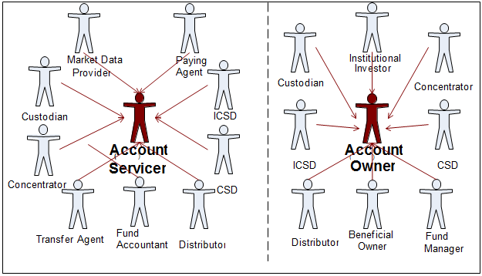

## Participants and BusinessRoles Definitions

Participants

|  |  |
| --- | --- |
| Description | Definition |
| Account Servicer | Party that manages the account on behalf of the account owner (that is, manages the registration and booking of entries on the account, calculates balances on the account and provides information about the account). |
| Account Owner | Party that legally holds the account or the party in a contractual relationship with the servicer. |

Business Roles

|  |  |
| --- | --- |
| Description | Definition |
| Custodian | Party that safekeeps and administers assets on behalf of the owner and that has a network of sub-custodians. |
| CSD / ICSD | Infrastructure that, holds or controls, the holding of physical or dematerialised financial instruments belonging to all, or a large portion of, the investors in a securities market. It effects the centralised transfer of ownership of such securities by entries on its books and records. The depository may delegate custody to another entity (custodian). |
| Market Data Provider | Source of financial information. It provides financial news and data (for example, facts, statistics and analysis), for professional and individual investors through various media (for example, the Internet, magazine). |
| Institutional Investor | Organisation whose primary purpose is to invest its own assets or those held in trust by it for others. Includes [investment companies](http://www.investorwords.com/2609/investment_company.html), [mutual funds](http://www.investorwords.com/3173/mutual_fund.html), [brokerages](http://www.investorwords.com/585/brokerage.html), [insurance companies](http://www.investorwords.com/6843/insurance_company.html), [pension funds](http://www.investorwords.com/3652/pension_fund.html), [investment banks](http://www.investorwords.com/2602/investment_bank.html). |
| Fund Manager | Entity that implements the fund's investment strategy, that is, selects portfolio investments in accordance with the objectives and strategy in the fund's prospectus, and places orders to effect or liquidate selected investments in accordance with net flow of capital into or out of the fund. |
| Beneficial Owner | Person(s) or entity entitled to the benefits of ownership even through another party such as a broker or bank (the nominal owner) and actually has possession and title to the security. (Source: <http://www.rbeck.com>). |
| Distributor | Party that act as a wholesaler of funds. |
| Concentrator | Party that acts as an aggregator of funds, also called funds hub. |
| Transfer Agent | Party appointed by the fund management company. This party updates records of investor accounts to reflect the daily investor purchases, redemptions, switches, transfers, and re-registrations. It ensures the timely settlement of transactions, and may provide tax information to the investor and/or to its intermediaries. It may calculate, collect, and rebate commissions. It prepares and distributes confirmations reflecting transactions, resulting in unit or cash account movements to the investor or the investor's intermediary. It responds to inquiries concerning account status, and processes the income distribution. |
| Fund Accountant | Party that keeps accounting records of the available assets and liabilities of the fund. This party calculates deal prices, the Net Asset Value (NAV) of the fund, and may provide fund performance and tax data. |
| Paying Agent | Agent that executes the payment. In the context of the investment fund industry, the paying agent is the local legal representative of the fund. It may pay out dividends, and collects money for the purchase of funds when a client deals directly with the fund and/or when a client deals with bearer shares. It pays out the redemption of the fund, may distribute information about the fund, and provides legal information about the fund. |

## BusinessRoles and Participants Table

|  |  |  |
| --- | --- | --- |
| BusinessRole | Participant  Account Servicer | Participant  Account Owner |
| Custodian | X | X |
| ICSD | X | X |
| CSD | X | X |
| Market Data Provider | X |  |
| Institutional Investor |  | X |
| Fund Manager |  | X |
| Beneficial Owner |  | X |
| Distributor | X | X |
| Concentrator | X | X |
| Transfer Agent | X |  |
| Fund Accountant | X |  |
| Paying Agent | X |  |

# BusinessProcess Description

This diagram represents the high level BusinessProcesses.



Holdings Reporting

|  |  |
| --- | --- |
| Item | Description |
| Definition | Records (shares, cash and holdings) and account details on the books of a party are compared/matched and brought into conformity with the records and account details on the books of another party, through the identification of discrepancies, determination of the correct value for any item where a discrepancy exists, and modification of the books of one or both parties to result in the correct value enabling full reconciliation of both parties. The reconciliation process is subdivided into 3 sub-processes::   * Custody reporting (not in scope of this MDR) * Accounting reporting (not in scope of this MDR) * Holdings reporting: provides transparency and the breakdown structure of the underlying holdings through a chain of custodians of one or several financial instruments. |
| Trigger: | * Time period as defined in SLA. * Time period as defined by regulator. * On request. * Completion of any transaction that affects account balances |
| Pre-conditions | Both parties involved maintain records for an account that is recognisably the same account. Both parties agree on the reconciliation process |
| Post-conditions | Parties agree (verbally, in writing) as to account details and balances, otherwise repeat process. Reconciliation is completed. |
| Roles | Account owner, account servicer |

# Description of BusinessActivities

This section presents the different BusinessActivities within each BusinessProcess. The BusinessActivities of a process are described with activity diagrams.

Legend

|  |  |  |
| --- | --- | --- |
| Symbol | Name | Definition |
|  | Start Point | Shows where the lifecycle of the business process commences. |
|  | End Point | Shows where the lifecycle of the business process may ends. |
|  | Lozenge (or diamond) | Indicates that a choice between several actions can be made. |
|  | Bar | Indicates that several actions are initiated in parallel. |

## Holdings Reporting

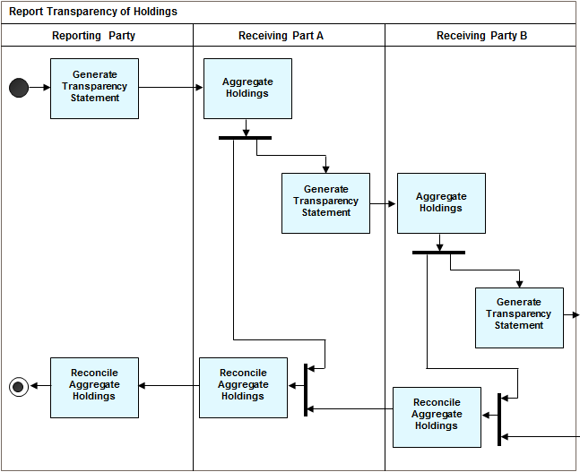

|  |  |  |
| --- | --- | --- |
| Step | Description | Initiator |
| Generate Transparency Statement | The reporting party generates a statement of the holdings containing all holdings reported  from customers to their custodian, “downstream” in the custody chain, providing transparency of holdings of customers of the customers and compiled with the customers’ inbound statements “upstream” in the custody chain, like a regular custody statement of holdings, from a custodian to their customers, aggregated with the inbound statements received from the respective customers and enriched with the same customer data as is reported to the fund company/transfer agent.  The purposes that the transparency of holdings statement has been designed for include:   * Disclosure of information about customers of customers * Verify/validate claims for retrocessions, rebates and commissions * Check compliance with laws, regulations and general terms and conditions. * Perform data analysis throughout custody chains, to identify geographic distribution patterns, measure the effects of targeted advertisement initiatives, and so on. | Reporting Party |
| Aggregate Holdings | Upon receipt of the Transparency of Holdings statement, the receiver combines data from its own books with the information received in the statement, and identifies any discrepancies to be reported as “account differences”. | Receiving Party (all levels) |
| Reconcile Aggregated Holdings | The receiver books all required updates in its own accounts for alignment. | Receiving Party (all levels) |

# BusinessTransactions

This section describes the message flows based on the activity diagrams documented above. It shows the typical exchanges of information in the context of a BusinessTransaction.

## Transparency of Holdings Reporting

An account servicer, such as a custodian, sends the SecuritiesBalanceTransparencyReport statement message to a receiver, who in turn, may enrich it with data of its own and send the aggregated statement onward in the custody chain.

The receiver of the message responds with the SecuritiesBalanceTransparencyReportStatusAdvice message to accept or reject the statement of holdings as presented in the aggregated statement.

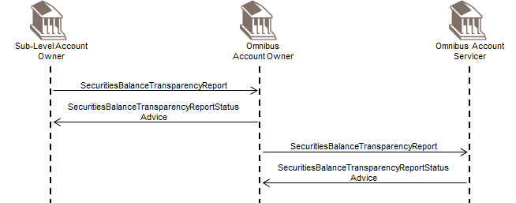

.

# Business Examples

This section describes business examples of the use of the MessageDefinitions.

## Transparency Of Holdings Reporting

This diagram shows a structural overview of the Securities Balance Transparency Report message:

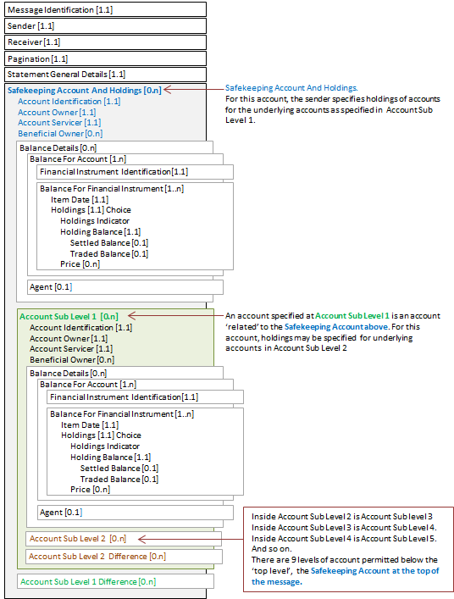

SecuritiesBalanceTransparencyReport semt.041.001.02 - 1

This diagram shows the flow of messages for the scenario illustrated by the business examples:

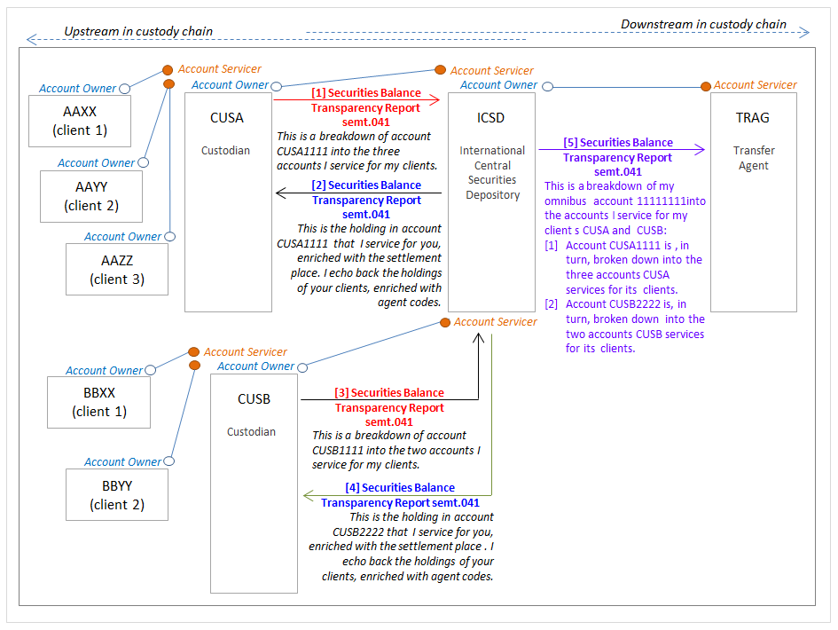

### SecuritiesBalanceTransparencyReport semt.041.001.02 Message 1

Message 1 from the above diagram

Description

CUSA (BIC CUSALULL) sends a SecuritiesBalanceTransparencyReport message to ICSD (BIC ICSDLULL) with a breakdown of the account that ICSD services for CUSA, account CUSA1111. (In the message, this account specified at the safekeeping account level.)

For this account, CUSA specifies the holdings of three accounts of its clients.

CUSA’s three clients account and holdings:

[1.1] Client AAXX (BIC AAXXLULL), account AAXX-c1. For ISIN LU1234567890, the aggregated settled balance is 90 units, the aggregated traded balance is 100 units. (In the message, this is specified at account sub level 1 repetition 1.)

[1.2] Client AAYY (BIC AAYYLLUU), account AAYY-c2. For ISIN LU1234567890, the aggregated settled balance is 110 units, the aggregated traded balance is 120 units. (In the message, this is specified at account sub level 1 repetition 2.)

[1.3] Client AAZZ (BIC AAZZLULL), account AAZZ-c3. For ISIN LU1234567890, the aggregated settled balance is 400 units, the aggregated traded balance is 420 units. (In the message, this is specified at account sub level 1 repetition 3.)

Message Instance

| Message Data | Comment |
| --- | --- |
| <SctiesBalTrnsprncyRpt> |  |
| <MsgId> |  |
| <Id>22AD-7834DC</Id> | Technical message reference. |
| <CreDtTm>2017-02-28T18:00:00</CreDtTm> | Creation date and time of the message. |
| </MsgId> |  |
| <SndrId> |  |
| <Id> |  |
| <AnyBIC>CUSALULL</AnyBIC> | Sender of the statement. |
| </Id> |  |
| </SndrId> |  |
| <RcvrId> |  |
| <Id> |  |
| <AnyBIC>ICSDLULL</AnyBIC> | Receiver of the statement. |
| </Id> |  |
| </RcvrId> |  |
| <Pgntn> |  |
| <PgNb>1</PgNb> | Statement only contains 1 page. |
| <LastPgInd>true</LastPgInd> |  |
| </Pgntn> |  |
| <StmtGnlDtls> |  |
| <SndrBizRole>AOWN</SndrBizRole> | Sender of the message is the owner of the safekeeping account in SafekeepingAccountAndHoldings/ AccountIdentification and is disclosing the breakdown of the underlying owners of the sender’s holdings with the receiver. |
| <StmtNb> |  |
| <Shrt>015</Shrt> | Statement number. |
| </StmtNb> |  |
| <StmtId>OH_1023</StmtId> | Statement identification. |
| <StmtDtTm> |  |
| <Dt>2017-02-28</Dt> | Statement date. |
| </StmtDtTm> |  |
| <StmtPrd> |  |
| <Dt>2017-02-27</Dt> | Statement period. |
| </StmtPrd> |  |
| <Frqcy> |  |
| <Cd>DAIL</Cd> | Statement is daily. |
| </Frqcy> |  |
| <UpdTp> |  |
| <Cd>COMP</Cd> | Statement contains activity. |
| </UpdTp> |  |
| <ActvtyInd>true</ActvtyInd> |  |
| </StmtGnlDtls> |  |
| <SfkpgAcctAndHldgs> |  |
| <AcctId> | Omnibus account of the sender. For this account, the sender specifies holdings of accounts it services for its underlying clients, AAXX, AAYY and AAZZ.  Owner of the account.  Account servicer. |
| <Id>CUSA1111</Id> |
| </AcctId> |
| <AcctOwnr> |
| <Id> |
| <AnyBIC>CUSALULL</AnyBIC> |
| </Id> |
| </AcctOwnr> |
| <AcctSvcr> |
| <Id> |
| <AnyBIC>ICSDLULL</AnyBIC> |
| </Id> |
| </AcctSvcr> |
| <AcctSubLvl1> | Start of Account Sub Level 1, repetition 1. |
| <AcctId> | Account that the sender, CUSA, services for its client AAXX. |
| <Id>AAXX-c1</Id> |
| </AcctId> |
| <AcctOwnr> |
| <Id> |
| <AnyBIC>AAXXLULL</AnyBIC> |
| </Id> |
| </AcctOwnr> |
| <AcctSvcr> |
| <Id> |
| <AnyBIC>CUSALULL</AnyBIC> |
| </Id> |
| </AcctSvcr> |
| <BalDtls> |  |
| <BalForAcct> |  |
| <FinInstrmId> |  |
| <ISIN>LU1234567890</ISIN> | Identification of the holding. |
| </FinInstrmId> |  |
| <BalForFinInstrm> |  |
| <ItmDt>2017-02-27</ItmDt> | Item date. |
| <Hldgs> |  |
| <HldgBal> |  |
| <SttldBal> |  |
| <Unit>90</Unit> | Settled balance. |
| </SttldBal> |  |
| <TraddBal> |  |
| <Unit>100</Unit> | Traded balance. |
| </TraddBal> |  |
| </HldgBal> |  |
| </Hldgs> |  |
| </BalForFinInstrm> |  |
| </BalForAcct> |  |
| </BalDtls> |  |
| </AcctSubLvl1> | End of Account Sub Level 1, repetition 1. |
| <AcctSubLvl1> | Start of Account Sub Level 1, repetition 2. |
| <AcctId> | Account that the sender, CUSA, services for its client AAYY. |
| <Id>AAYY-c2</Id> |
| </AcctId> |
| <AcctOwnr> |
| <Id> |
| <AnyBIC>AAYYLULL</AnyBIC> |
| </Id> |
| </AcctOwnr> |
| <AcctSvcr> |
| <Id> |
| <AnyBIC>CUSALULL</AnyBIC> |
| </Id> |
| </AcctSvcr> |
| <BalDtls> |  |
| <BalForAcct> |  |
| <FinInstrmId> |  |
| <ISIN>LU1234567890</ISIN> | Identification of the holding. |
| </FinInstrmId> |  |
| <BalForFinInstrm> |  |
| <ItmDt>2017-02-27</ItmDt> | Item date. |
| <Hldgs> |  |
| <HldgBal> |  |
| <SttldBal> |  |
| <Unit>110</Unit> | Settled balance. |
| </SttldBal> |  |
| <TraddBal> |  |
| <Unit>120</Unit> | Traded balance. |
| </TraddBal> |  |
| </HldgBal> |  |
| </Hldgs> |  |
| </BalForFinInstrm> |  |
| </BalForAcct> |  |
| </BalDtls> |  |
| </AcctSubLvl1> | End of Account Sub Level 1, repetition 2. |
| <AcctSubLvl1> | Start of Account Sub Level 1, repetition 3. |
| <AcctId> | Account that the sender, CUSA, services for its client AAZZ |
| <Id>AAZZ-c3</Id> |
| </AcctId> |
| <AcctOwnr> |
| <Id> |
| <AnyBIC>AAZZLULL</AnyBIC> |
| </Id> |
| </AcctOwnr> |
| <AcctSvcr> |
| <Id> |
| <AnyBIC>CUSALULL</AnyBIC> |
| </Id> |
| </AcctSvcr> |
| <BalDtls> |  |
| <BalForAcct> |  |
| <FinInstrmId> |  |
| <ISIN>LU1234567890</ISIN> | Identification of the holding. |
| </FinInstrmId> |  |
| <BalForFinInstrm> |  |
| <ItmDt>2017-02-27</ItmDt> | Item date. |
| <Hldgs> |  |
| <HldgBal> |  |
| <SttldBal> |  |
| <Unit>400</Unit> | Settled balance. |
| </SttldBal> |  |
| <TraddBal> |  |
| <Unit>420</Unit> | Traded balance. |
| </TraddBal> |  |
| </HldgBal> |  |
| </Hldgs> |  |
| </BalForFinInstrm> |  |
| </BalForAcct> |  |
| </BalDtls> |  |
| </AcctSubLvl1> | End of Account Sub Level 1, repetition 3. |
| </SfkpgAcctAndHldgs> |  |
| </SctiesBalTrnsprncyRpt> |  |

Diagrammatical Overview

This diagram represents a simplified view of the Safekeeping Account And Holdings sequence of the xml message above.

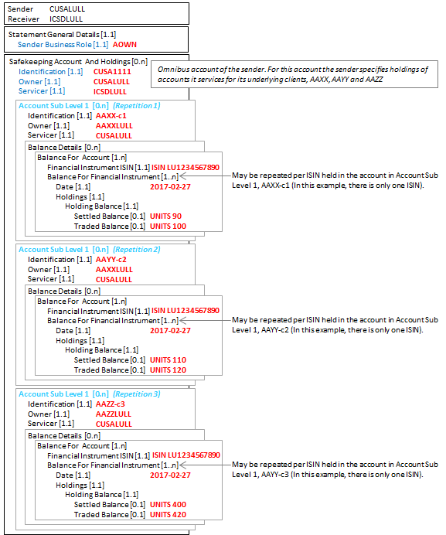

### SecuritiesBalanceTransparencyReport semt.041.001.02 Message 2

Message 2 from the above diagram

Description

ICSD (BIC ICSDLULL), having received a SecuritiesBalanceTransparencyReport message from CUSA (BIC CUSALULL), with the details of CUSA’s three customer accounts, sends a SecuritiesBalanceTransparencyReport message back to CUSA.

[1] The data is enriched with the place where the securities are held. The securities are held at TRAG, account 111111. (In the message, this is specified at safekeeping account level.)

[2] For account CUSA1111, the data is enriched with the holding and balance information. The holding is ISIN LU1234567890, the aggregated settled balance is 600 units and the aggregated traded balance is 640 units. (In the message, this is specified at account sub level 1.)

[3] In addition, the account data provided in the message received (message 1 in the flow) is echoed back and enriched with agent code information for CUSA’s underlying customer accounts:

CUSA’s three clients account and holdings:

[1.1] Client AAXX (BIC AAXXLULL), account AAXX-c1. For ISIN LU1234567890, the aggregated settled balance is 90 units, the aggregated traded balance is 100 units.

The agent code for this client for this holding is 77777, issued by TRAGLULL, the role is distributor.

(In the message, this is specified at account sub level 2 repetition 1.)

[1.2] Client AAYY (BIC AAYYLULL), account AAYY-c2. For ISIN LU1234567890, the aggregated settled balance is 110 units, the aggregated traded balance is 120 units.

The agent code for this client for this holding is AGNTLULL, a distributor.

(In the message, this is specified at account sub level 2 repetition 2.)

[1.3] Client AAZZ (BIC AAZZLULL), account AAZZ-c3. For ISIN LU1234567890, the aggregated settled balance is 400 units, the traded balance is 420 units.

The agent for this client for this holding is DISTLULL, a distributor.

(In the message, this is specified at account sub level 2 repetition 3.)

Message Instance

| Message Data | Comment |
| --- | --- |
| <SctiesBalTrnsprncyRpt> |  |
| <MsgId> |  |
| <Id>803FC-43AC</Id> | Technical message reference. |
| <CreDtTm>2017-03-01T18:00:00</CreDtTm> | Creation date and time of the message. |
| </MsgId> |  |
| <SndrId> |  |
| <Id> |  |
| <AnyBIC>ICSDLULL</AnyBIC> | Sender of the statement. |
| </Id> |  |
| </SndrId> |  |
| <RcvrId> |  |
| <Id> |  |
| <AnyBIC>CUSALULL</AnyBIC> | Receiver of the statement. |
| </Id> |  |
| </RcvrId> |  |
| <Pgntn> |  |
| <PgNb>1</PgNb> | Statement only contains 1 page. |
| <LastPgInd>true</LastPgInd> |  |
| </Pgntn> |  |
| <StmtGnlDtls> |  |
| <SndrBizRole>ASER</SndrBizRole> | Sender of the message is the servicer of the account in ‘Account Sub Level 1 / Account Identification (<AcctSubLvl1><AcctId>) |
| <StmtNb> | Statement number. |
| <Shrt>101</Shrt> |  |
| </StmtNb> | Statement identification. |
| <StmtId>C1-004</StmtId> |  |
| <StmtDtTm> |  |
| <Dt>2017-03-01</Dt> | Statement date. |
| </StmtDtTm> |  |
| <StmtPrd> |  |
| <Dt>2017-02-27</Dt> | Statement period. |
| </StmtPrd> |  |
| <Frqcy> |  |
| <Cd>DAIL</Cd> | Statement is daily. |
| </Frqcy> |  |
| <UpdTp> |  |
| <Cd>COMP</Cd> |  |
| </UpdTp> |  |
| <ActvtyInd>true</ActvtyInd> |  |
| </StmtGnlDtls> |  |
| <SfkpgAcctAndHldgs> |  |
| <AcctId> | Place were the securities are kept (at ICSD’s account at TRAG (enrichment).  For this account, the sender specifies holdings of accounts it services for its underlying client, CUSA. |
| <Id>11111111</Id> |
| </AcctId> |
| <AcctOwnr> |
| <Id> |
| <AnyBIC>ICSDLULL</AnyBIC> |
| </Id> |
| </AcctOwnr> |
| <AcctSvcr> |
| <Id> |
| <AnyBIC>TRAGLULL</AnyBIC> |
| </Id> |
| </AcctSvcr> |
| <AcctSubLvl1> | Start of Account Sub Level 1, repetition 1. |
| <AcctId> | Account that the sender, ICSD, services for its client CUSA. |
| <Id>CUSA1111</Id> |
| </AcctId> |
| <AcctOwnr> |
| <Id> |
| <AnyBIC>CUSALULL</AnyBIC> |
| </Id> |
| </AcctOwnr> |
| <AcctSvcr> |
| <Id> |
| <AnyBIC>ICSDLULL</AnyBIC> |
| </Id> |
| </AcctSvcr> |
| <BalDtls> |  |
| <BalForAcct> |  |
| <FinInstrmId> |  |
| <ISIN>LU1234567890</ISIN> | Identification of the holding. |
| </FinInstrmId> |  |
| <BalForFinInstrm> |  |
| <ItmDt>2017-02-27</ItmDt> | Item date. |
| <Hldgs> |  |
| <HldgBal> |  |
| <SttldBal> | Settled balance of account CUSA1111. This may be sum of the three settlement balance elements for the accounts reported at sub level 2. (If not then, this is reported in the AccountSubLevel2Difference element.) |
| <Unit>600</Unit> |
| </SttldBal> |
| <TraddBal> | Traded balance of account CUSA1111. This may be sum of the three traded balance elements for the accounts reported at sub level 2. (If not then this is reported in the AccountSubLevel2Differenceelement.) |
| <Unit>640</Unit> |
| </TraddBal> |
| </HldgBal> |  |
| </Hldgs> |  |
| </BalForFinInstrm> |  |
| </BalForAcct> |  |
| </BalDtls> |  |
| <AcctSubLvl2> | Start of Account Sub Level 2, repetition 1. |
| <AcctId> | Account that the client of ICSD, CUSA, in turn, services for its client AAXX |
| <Id>AAXX-c1</Id> |
| </AcctId> |
| <AcctOwnr> |
| <Id> |
| <AnyBIC>AAXXLULL</AnyBIC> |
| </Id> |
| </AcctOwnr> |
| <AcctSvcr> |
| <Id> |
| <AnyBIC>CUSALULL</AnyBIC> |
| </Id> |
| </AcctSvcr> |
| <BalDtls> |  |
| <BalForAcct> |  |
| <FinInstrmId> |  |
| <ISIN>LU1234567890</ISIN> | Identification of the holding. |
| </FinInstrmId> |  |
| <BalForFinInstrm> |  |
| <ItmDt>2017-02-27</ItmDt> | Item date. |
| <Hldgs> |  |
| <HldgBal> |  |
| <SttldBal> |  |
| <Unit>90</Unit> | Settled balance. |
| </SttldBal> |  |
| <TraddBal> |  |
| <Unit>100</Unit> | Traded balance. |
| </TraddBal> |  |
| </HldgBal> |  |
| </Hldgs> |  |
| </BalForFinInstrm> |  |
| </BalForAcct> |  |
| <Agt> | Agent code for AAXX that has been assigned by the transfer agent (enrichment by the sender, ICSD). |
| <Id> |
| <Id> |
| <PrtryId> |
| <Id>77777</Id> |
| <Issr>TRAGLULL</Issr> |
| </PrtryId> |
| </Id> |
| </Id> |
| <Role> |
| <Cd>DIST</Cd> |
| </Role> |
| </Agt> |
| </BalDtls> |  |
| </AcctSubLvl2> | End of Account Sub Level 2, repetition 1. |
| <AcctSubLvl2> | Start of Account Sub Level 2, repetition 2. |
| <AcctId> | Account that the client of ICSD, CUSA, in turn, services for its client AAYY. |
| <Id>AAYY-c2</Id> |
| </AcctId> |
| <AcctOwnr> |
| <Id> |
| <AnyBIC>AAYYLULL</AnyBIC> |
| </Id> |
| </AcctOwnr> |
| <AcctSvcr> |
| <Id> |
| <AnyBIC>CUSALULL</AnyBIC> |
| </Id> |
| </AcctSvcr> |
| <BalDtls> |  |
| <BalForAcct> |  |
| <FinInstrmId> |  |
| <ISIN>LU1234567890</ISIN> | Identification of the holding. |
| </FinInstrmId> |  |
| <BalForFinInstrm> |  |
| <ItmDt>2017-02-27</ItmDt> | Item date. |
| <Hldgs> |  |
| <HldgBal> |  |
| <SttldBal> |  |
| <Unit>110</Unit> | Settled balance. |
| </SttldBal> |  |
| <TraddBal> |  |
| <Unit>120</Unit> | Traded balance. |
| </TraddBal> |  |
| </HldgBal> |  |
| </Hldgs> |  |
| </BalForFinInstrm> |  |
| </BalForAcct> |  |
| <Agt> | Agent code for AAYY (enrichment by the sender, ICSD). |
| <Id> |
| <Id> |
| <AnyBIC>AGNTLULL</AnyBIC> |
| </Id> |
| </Id> |
| <Role> |
| <Cd>DIST</Cd> |
| </Role> |
| </Agt> |
| </BalDtls> |  |
| </AcctSubLvl2> | End of Account Sub Level 2, repetition 2. |
| <AcctSubLvl2> | Start of Account Sub Level 2, repetition 3. |
| <AcctId> | Account that the client of ICSD, CUSA, in turn, services for its client AAZZ. |
| <Id>AAZZ-c3</Id> |
| </AcctId> |
| <AcctOwnr> |
| <Id> |
| <AnyBIC>AAZZLULL</AnyBIC> |
| </Id> |
| </AcctOwnr> |
| <AcctSvcr> |
| <Id> |
| <AnyBIC>CUSALULL</AnyBIC> |
| </Id> |
| </AcctSvcr> |
| <BalDtls> |  |
| <BalForAcct> |  |
| <FinInstrmId> |  |
| <ISIN>LU1234567890</ISIN> | Identification of the holding. |
| </FinInstrmId> |  |
| <BalForFinInstrm> |  |
| <ItmDt>2017-02-27</ItmDt> | Item date. |
| <Hldgs> |  |
| <HldgBal> |  |
| <SttldBal> |  |
| <Unit>400</Unit> | Settled balance. |
| </SttldBal> |  |
| <TraddBal> |  |
| <Unit>420</Unit> | Traded balance. |
| </TraddBal> |  |
| </HldgBal> |  |
| </Hldgs> |  |
| </BalForFinInstrm> |  |
| </BalForAcct> |  |
| <Agt> | Agent code for AAYY (enrichment by the sender, ICSD). |
| <Id> |
| <Id> |
| <AnyBIC>DISTLULL</AnyBIC> |
| </Id> |
| </Id> |
| <Role> |
| <Cd>DIST</Cd> |
| </Role> |
| </Agt> |
| </BalDtls> |  |
| </AcctSubLvl2> | End of Account Sub Level 2, repetition 3. |
| </AcctSubLvl1> | End of Account Sub Level 1, repetition 1. |
| </SfkpgAcctAndHldgs> |  |
| </SctiesBalTrnsprncyRpt> |  |

Diagrammatic Overview

This diagram represents a simplified view of the safekeeping account sequence with sub level 1 and sub level 2 account sequences from the xml message above.

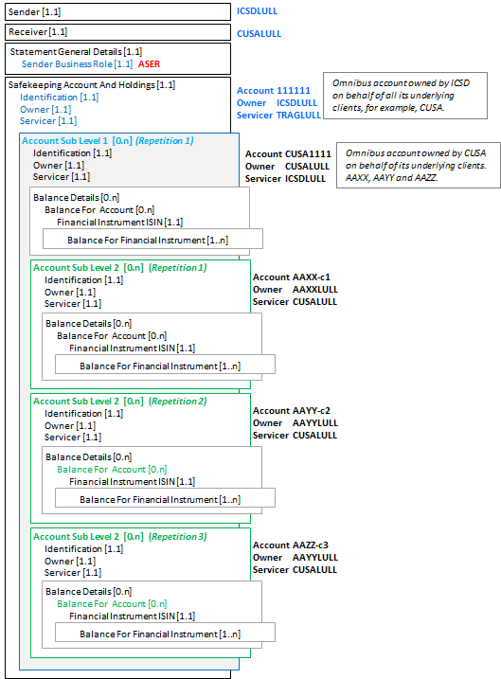

### SecuritiesBalanceTransparencyReport semt.041.001.02 Message 3

Message 3 from the above diagram

Description

ICSD (BIC ICSDLULL) receives a similar SecuritiesBalanceTransparencyReport message from CUSB (BIC CUSBLULL) for its account and the accounts CUSB services for its two clients, BBXX and BBYY.

This XML message, message 3, is not shown.

### SecuritiesBalanceTransparencyReport semt.041.001.02 Message 4

Messages 4 from the above diagram

Description

Having received a SecuritiesBalanceTransparencyReport message from CUSB (BIC CUSBLULL) for its account and the accounts CUSB services for its two clients, BBXX and BBYY, ICSD (BIC ICSDLULL), ICSD may respond with an enriched SecuritiesBalanceTransparencyReport message, enriched with the place of safekeeping and agent code information for CUSB’s two client accounts.

This XML message, message 4, is not shown.

### SecuritiesBalanceTransparencyReport semt.041.001.02 Message 5

Message 5 from the above diagram

ICSD is now in a position to send a SecuritiesBalanceTransparencyReport to TRAG with full information about its clients and the clients of its clients. This provides:

[1] Identification of ICSD’s account at TRAG

[2] Account information for ICSD’s customer, AAAA, account CUSA1111, and its three underlying client accounts

[3] Account information for ICSD’s customer, BBBB, account CUSB1111, and its two underlying client accounts

Description

ICSD (BIC ICSDLULL) sends a SecuritiesBalanceTransparencyReport message to TRAG (BIC TRAGLULL) with a breakdown of holdings in its omnibus, account 11111111 (in the message, this is specified at safekeeping account level), into the customer accounts that ICSD, in turn, services for its two clients.

[1] ICSDs first client, custodian CUSA (BIC CUSALULL), account CUSA1111

For account CUSA1111, the holding is ISIN LU1234567890, the aggregated settled balance is 600 units, the aggregate traded balance is 640 units. (in the message, this data is specified at account sub level 1, 1st repetition)

CUSA’s three clients account and holdings

[1.1] Client AAXX (BIC AAXXLULL), account AAXX-c1. For ISIN LU1234567890, the aggregated settled balance is 90 units, the aggregated traded balance is 100 units.

The agent code for this client for this holding is 77777, issued by TRAGLULL, the role is distributor.

(In the message, this is specified at account sub level 2 repetition 1.)

[1.2] Client AAYY (BIC AAYYLULL), account AAYY-c2. For ISIN LU1234567890, the aggregated settled balance is 110 units, the aggregated traded balance is 120 units.

The agent code for this client for this holding is AGNTLULL, a distributor.

(In the message, this data is specified at account sub level 2 repetition 2.)

[1.3] Client AAZZ (BIC AAZZLULL), account AAZZ-c3. For ISIN LU1234567890, the aggregated settled balance is 400 units, the aggregated traded balance is 420 units.

The agent for this client for this holding is DISTLULL, a distributor.

(In the message, this data is specified at account sub level 2 repetition 3.)

[2] ICSDs second client, custodian CUSB (BIC CUSBLULL), account CUSB2222

For account CUSB2222, the holding is ISIN LU1234567890, the aggregated settled balance is 1000 units, the aggregate traded balance is 1200 units. (in the message, this data specified at account sub level 1, 1st repetition)

CUSB’s two clients account and holdings

[2.1] Client BBXX (BIC BBXXLULL), account BBXX-c1. For ISIN LU1234567890, the aggregated settled balance is 600 units, the aggregated traded balance is 700 units.

The agent code for this client for this holding is, 77777, issued by TRAGLULL, a distributor.

(In the message, this data is specified at account sub level 2 repetition 1.)

[2.2] Client BBYY (BIC BBYYLULL), account BBYY-c2. For ISIN LU1234567890, the aggregated settled balance is 400 units, the aggregated traded balance is 500 units.

The agent code for this client for this holding is AGNTLULL, a distributor.

(In the message, this data is specified at account sub level 2 repetition 2.)

Message Instance - message 5

| Message Data | Comment |
| --- | --- |
| <SctiesBalTrnsprncyRpt> |  |
| <MsgId> |  |
| <Id>803FC-66AC</Id> | Technical message reference. |
| <CreDtTm>2017-03-01T18:00:00</CreDtTm> | Creation date and time of the message. |
| </MsgId> |  |
| <SndrId> |  |
| <Id> |  |
| <AnyBIC>ICSDLULL</AnyBIC> | Sender of the statement. |
| </Id> |  |
| </SndrId> |  |
| <RcvrId> |  |
| <Id> |  |
| <AnyBIC>TRAGLULL</AnyBIC> | Receiver of the statement. |
| </Id> |  |
| </RcvrId> |  |
| <Pgntn> |  |
| <PgNb>1</PgNb> | Statement only contains 1 page. |
| <LastPgInd>true</LastPgInd> |  |
| </Pgntn> |  |
| <StmtGnlDtls> |  |
| <SndrBizRole>AOWN</SndrBizRole> | Sender of the message is the owner of the safekeeping account in SafekeepingAccountAndHoldings/ AccountIdentification and is disclosing the breakdown of the underlying owners of the sender’s holdings with the receiver. |
| <StmtNb> |  |
| <Shrt>120</Shrt> | Statement number. |
| </StmtNb> |  |
| <StmtId>T2-006</StmtId> | Statement identification. |
| <StmtDtTm> |  |
| <Dt>2017-03-01</Dt> | Statement date. |
| </StmtDtTm> |  |
| <StmtPrd> |  |
| <Dt>2017-02-27</Dt> | Statement period. |
| </StmtPrd> |  |
| <Frqcy> |  |
| <Cd>DAIL</Cd> | Statement is daily. |
| </Frqcy> |  |
| <UpdTp> |  |
| <Cd>COMP</Cd> |  |
| </UpdTp> |  |
| <ActvtyInd>true</ActvtyInd> |  |
| </StmtGnlDtls> |  |
| <SfkpgAcctAndHldgs> |  |
| <AcctId> | Omnibus account for which the sender specifies holdings of accounts it services for its underlying clients CUSA and CUSB.  Owner of the account.  Account Servicer |
| <Id>11111111</Id> |
| </AcctId> |
| <AcctOwnr> |
| <Id> |
| <AnyBIC>ICSDLULL</AnyBIC> |
| </Id> |
| </AcctOwnr> |
| <AcctSvcr> |
| <Id> |
| <AnyBIC>TRAGLULL</AnyBIC> |
| </Id> |
| </AcctSvcr> |
| <AcctSubLvl1> | Start of Account Sub Level 1, repetition 1. |
| <AcctId> | Account that the sender, ICSD, services for its client CUSA. |
| <Id>CUSA111</Id> |
| </AcctId> |
| <AcctOwnr> |
| <Id> |
| <AnyBIC>CUSALULL</AnyBIC> |
| </Id> |
| </AcctOwnr> |
| <AcctSvcr> |
| <Id> |
| <AnyBIC>ICSDLULL</AnyBIC> |
| </Id> |
| </AcctSvcr> |
| <BalDtls> |  |
| <BalForAcct> |  |
| <FinInstrmId> |  |
| <ISIN>LU1234567890</ISIN> | Identification of the holding. |
| </FinInstrmId> |  |
| <BalForFinInstrm> |  |
| <ItmDt>2017-02-27</ItmDt> | Item date. |
| <Hldgs> |  |
| <HldgBal> |  |
| <SttldBal> |  |
| <Unit>600</Unit> | Settled balance. |
| </SttldBal> |  |
| <TraddBal> |  |
| <Unit>640</Unit> | Traded balance. |
| </TraddBal> |  |
| </HldgBal> |  |
| </Hldgs> |  |
| </BalForFinInstrm> |  |
| </BalForAcct> |  |
| </BalDtls> |  |
| <AcctSubLvl2> | Start of Account Sub Level 2, repetition 1. |
| <AcctId> | Account serviced by CUSA for its client AAXX. |
| <Id>AAXX-c1</Id> |
| </AcctId> |
| <AcctOwnr> |
| <Id> |
| <AnyBIC>AAXXLULL</AnyBIC> |
| </Id> |
| </AcctOwnr> |
| <AcctSvcr> |
| <Id> |
| <AnyBIC>CUSALULL</AnyBIC> |
| </Id> |
| </AcctSvcr> |
| <BalDtls> |  |
| <BalForAcct> |  |
| <FinInstrmId> |  |
| <ISIN>LU1234567890</ISIN> | Identification of the holding. |
| </FinInstrmId> |  |
| <BalForFinInstrm> |  |
| <ItmDt>2017-02-27</ItmDt> | Item date. |
| <Hldgs> |  |
| <HldgBal> |  |
| <SttldBal> |  |
| <Unit>90</Unit> | Settled balance. |
| </SttldBal> |  |
| <TraddBal> |  |
| <Unit>100</Unit> | Traded balance |
| </TraddBal> |  |
| </HldgBal> |  |
| </Hldgs> |  |
| </BalForFinInstrm> |  |
| </BalForAcct> |  |
| <Agt> | Agent code for AAXX that has been assigned by the transfer agent (enrichment by the sender, ICSD). |
| <Id> |
| <Id> |
| <PrtryId> |
| <Id>77777</Id> |
| <Issr>TRAGLULL</Issr> |
| </PrtryId> |
| </Id> |
| </Id> |
| <Role> |
| <Cd>DIST</Cd> |
| </Role> |
| </Agt> |
| </BalDtls> |  |
| </AcctSubLvl2> | End of Account Sub Level 2, repetition 1. |
| <AcctSubLvl2> | Start of Account Sub Level 2, repetition 2. |
| <AcctId> | Account serviced by CUSA for its client AAYY. |
| <Id>AAYY-c2</Id> |
| </AcctId> |
| <AcctOwnr> |
| <Id> |
| <AnyBIC>AAYYLULL</AnyBIC> |
| </Id> |
| </AcctOwnr> |
| <AcctSvcr> |
| <Id> |
| <AnyBIC>CUSALULL</AnyBIC> |
| </Id> |
| </AcctSvcr> |
| <BalDtls> |  |
| <BalForAcct> |  |
| <FinInstrmId> |  |
| <ISIN>LU1234567890</ISIN> | Identification of the holding. |
| </FinInstrmId> |  |
| <BalForFinInstrm> |  |
| <ItmDt>2017-02-27</ItmDt> | Item date. |
| <Hldgs> |  |
| <HldgBal> |  |
| <SttldBal> |  |
| <Unit>110</Unit> | Settled balance. |
| </SttldBal> |  |
| <TraddBal> |  |
| <Unit>120</Unit> | Traded balance |
| </TraddBal> |  |
| </HldgBal> |  |
| </Hldgs> |  |
| </BalForFinInstrm> |  |
| </BalForAcct> |  |
| <Agt> | Agent code for AAYY that has been assigned by the transfer agent (enrichment by the sender, ICSD). |
| <Id> |
| <Id> |
| <AnyBIC>AGNTLULL</AnyBIC> |
| </Id> |
| </Id> |
| <Role> |
| <Cd>DIST</Cd> |
| </Role> |
| </Agt> |
| </BalDtls> |  |
| </AcctSubLvl2> | End of Account Sub Level 2, repetition 2. |
| <AcctSubLvl2> | Start of Account Sub Level 2, repetition 3. |
| <AcctId> | Account serviced by CUSA for its client AAZZ. |
| <Id>AAZZ-c3</Id> |
| </AcctId> |
| <AcctOwnr> |
| <Id> |
| <AnyBIC>AAZZLULL</AnyBIC> |
| </Id> |
| </AcctOwnr> |
| <AcctSvcr> |
| <Id> |
| <AnyBIC>CUSALULL</AnyBIC> |
| </Id> |
| </AcctSvcr> |
| <BalDtls> |  |
| <BalForAcct> |  |
| <FinInstrmId> |  |
| <ISIN>LU1234567890</ISIN> | Identification of the holding. |
| </FinInstrmId> |  |
| <BalForFinInstrm> |  |
| <ItmDt>2017-02-27</ItmDt> | Item date. |
| <Hldgs> |  |
| <HldgBal> |  |
| <SttldBal> |  |
| <Unit>400</Unit> | Settled balance. |
| </SttldBal> |  |
| <TraddBal> |  |
| <Unit>420</Unit> | Traded balance |
| </TraddBal> |  |
| </HldgBal> |  |
| </Hldgs> |  |
| </BalForFinInstrm> |  |
| </BalForAcct> |  |
| <Agt> | Agent code for AAZZ that has been assigned by the transfer agent (enrichment by the sender, ICSD). |
| <Id> |
| <Id> |
| <AnyBIC>DISTLULL</AnyBIC> |
| </Id> |
| </Id> |
| <Role> |
| <Cd>DIST</Cd> |
| </Role> |
| </Agt> |
| </BalDtls> |  |
| </AcctSubLvl2> | End of Account Sub Level 2, repetition 3 |
| </AcctSubLvl1> | End of Account Sub Level 1, repetition 1. |
| <AcctSubLvl1> | Start of Account Sub Level 1, repetition 2. |
| <AcctId> | Account that the sender, ICSD, services for its client CUSB. |
| <Id>CUSB2222</Id> |
| </AcctId> |
| <AcctOwnr> |
| <Id> |
| <AnyBIC>CUSBLULL</AnyBIC> |
| </Id> |
| </AcctOwnr> |
| <AcctSvcr> |
| <Id> |
| <AnyBIC>ICSDLULL</AnyBIC> |
| </Id> |
| </AcctSvcr> |
| <BalDtls> |  |
| <BalForAcct> |  |
| <FinInstrmId> |  |
| <ISIN>LU1234567890</ISIN> | Identification of the holding. |
| </FinInstrmId> |  |
| <BalForFinInstrm> |  |
| <ItmDt>2017-02-27</ItmDt> | Item date. |
| <Hldgs> |  |
| <HldgBal> |  |
| <SttldBal> |  |
| <Unit>1000</Unit> | Settled balance. |
| </SttldBal> |  |
| <TraddBal> |  |
| <Unit>1200</Unit> | Traded balance. |
| </TraddBal> |  |
| </HldgBal> |  |
| </Hldgs> |  |
| </BalForFinInstrm> |  |
| </BalForAcct> |  |
| </BalDtls> |  |
| <AcctSubLvl2> | Start of Account Sub Level 2, repetition 1. |
| <AcctId> | Account serviced by CUSA for its client BBXX. |
| <Id>BBXX-c1</Id> |
| </AcctId> |
| <AcctOwnr> |
| <Id> |
| <AnyBIC>BBXXLULL</AnyBIC> |
| </Id> |
| </AcctOwnr> |
| <AcctSvcr> |
| <Id> |
| <AnyBIC>CUSBLULL</AnyBIC> |
| </Id> |
| </AcctSvcr> |
| <BalDtls> |  |
| <BalForAcct> |  |
| <FinInstrmId> |  |
| <ISIN>LU1234567890</ISIN> | Identification of the holding. |
| </FinInstrmId> |  |
| <BalForFinInstrm> |  |
| <ItmDt>2017-02-27</ItmDt> | Item date. |
| <Hldgs> |  |
| <HldgBal> |  |
| <SttldBal> |  |
| <Unit>600</Unit> | Settled balance. |
| </SttldBal> |  |
| <TraddBal> |  |
| <Unit>700</Unit> | Traded balance. |
| </TraddBal> |  |
| </HldgBal> |  |
| </Hldgs> |  |
| </BalForFinInstrm> |  |
| </BalForAcct> |  |
| </BalDtls> |  |
| </AcctSubLvl2> | End of Account Sub Level 2, repetition 1. |
| <AcctSubLvl2> | Start of Account Sub Level 2, repetition 2. |
| <AcctId> | Account serviced by CUSA for its client BBYY. |
| <Id>BBYY-c2</Id> |
| </AcctId> |
| <AcctOwnr> |
| <Id> |
| <AnyBIC>BBYYLULL</AnyBIC> |
| </Id> |
| </AcctOwnr> |
| <AcctSvcr> |
| <Id> |
| <AnyBIC>CUSBLULL</AnyBIC> |
| </Id> |
| </AcctSvcr> |
| <BalDtls> |  |
| <BalForAcct> |  |
| <FinInstrmId> |  |
| <ISIN>LU1234567890</ISIN> | Identification of the holding. |
| </FinInstrmId> |  |
| <BalForFinInstrm> |  |
| <ItmDt>2017-02-27</ItmDt> | Item date. |
| <Hldgs> |  |
| <HldgBal> |  |
| <SttldBal> |  |
| <Unit>400</Unit> | Settled balance. |
| </SttldBal> |  |
| <TraddBal> |  |
| <Unit>500</Unit> | Traded balance |
| </TraddBal> |  |
| </HldgBal> |  |
| </Hldgs> |  |
| </BalForFinInstrm> |  |
| </BalForAcct> |  |
| </BalDtls> |  |
| </AcctSubLvl2> | End of Account Sub Level 2, repetition 2. |
| </AcctSubLvl1> | End of Account Sub Level 1, repetition 2 |
| </SfkpgAcctAndHldgs> |  |
| </SctiesBalTrnsprncyRpt> |  |

Diagrammatic Overview

This diagram represents a simplified view of the safekeeping account sequence with sub level 1 and sub level 2 account sequences.

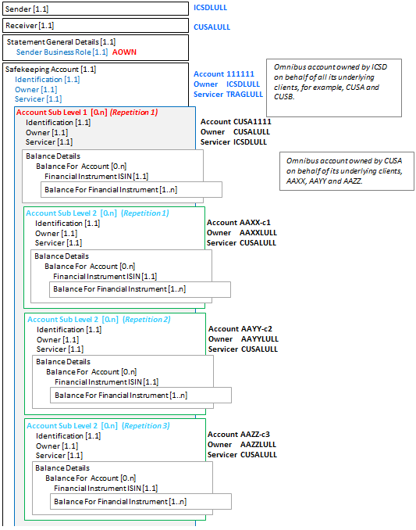

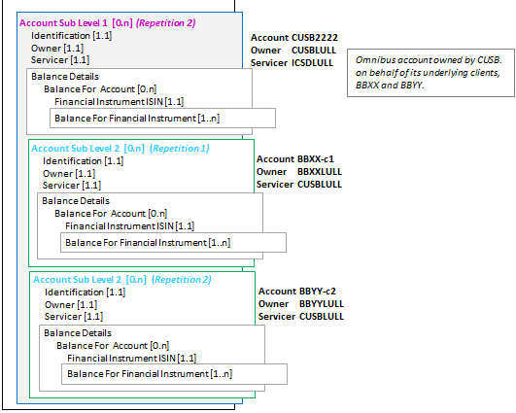

### SecuritiesBalanceTransparencyReport semt.041.001.02 - 2

This diagram shows the flow of messages for the scenario illustrated by the business examples.

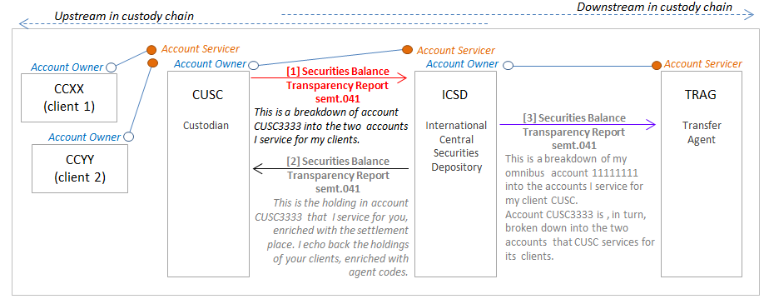

### SecuritiesBalanceTransparencyReport semt.041.001.02 Message 1

Message 1 from the above diagram

Description

CUSC (BIC CUSCLULL) sends a SecuritiesBalanceTransparencyReport message to ICSD (BIC ICSDLULL) with a breakdown of the account that ICSD services for CUSC, account CUSC3333. (In the message, this account specified at the safekeeping account level.)

For this account, CUSC specifies the holdings of two accounts of its clients.

CUSC’s two clients account and holdings

[1.1] Client CCXX (BIC CCXXLULL), account CCXX-c1. For ISIN LU1234567890, the aggregated settled balance is 1500 units, the aggregated traded balance is 1700 units. (In the message, this is specified at account sub level 1 repetition 1.)

The following balance breakdowns are specified:

150 units are traded and pending settlement (PNET).

50 units are traded and pending settlement is overdue (OPNT).

[1.2] Client CCYY (BIC CCYYLULL), account CCYY-c2. For ISIN LU1234567890, the aggregated settled balance is 4700 units, the aggregated traded balance is 5000 units. (In the message, this is specified at account sub level 1 repetition 2.)

The following balance breakdowns are specified:

260 units are traded and pending settlement (PNET).

40 units are traded and pending settlement is overdue (OPNT).

| Message Data | Comment |
| --- | --- |
| <SctiesBalTrnsprncyRpt> |  |
| <MsgId> |  |
| <Id>17AF-567CD</Id> | Technical message reference. |
| <CreDtTm>2017-03-02T18:00:00</CreDtTm> | Creation date and time of the message. |
| </MsgId> |  |
| <SndrId> |  |
| <Id> |  |
| <AnyBIC>CUSCLULL</AnyBIC> | Sender of the statement. |
| </Id> |  |
| </SndrId> |  |
| <RcvrId> |  |
| <Id> |  |
| <AnyBIC>ICSDLULL</AnyBIC> | Receiver of the statement. |
| </Id> |  |
| </RcvrId> |  |
| <Pgntn> |  |
| <PgNb>1</PgNb> | Statement only contains 1 page. |
| <LastPgInd>true</LastPgInd> |  |
| </Pgntn> |  |
| <StmtGnlDtls> |  |
| <SndrBizRole>AOWN</SndrBizRole> | Sender of the message is the owner of the safekeeping account in SafekeepingAccountAndHoldings/ AccountIdentification and is disclosing the breakdown of the underlying owners of the sender’s holdings with the receiver. |
| <StmtNb> |  |
| <Shrt>003</Shrt> | Statement number. |
| </StmtNb> |  |
| <StmtId>STRANS</StmtId> | Statement identification. |
| <StmtDtTm> |  |
| <Dt>2017-03-02</Dt> | Statement date. |
| </StmtDtTm> |  |
| <StmtPrd> |  |
| <Dt>2017-02-27</Dt> | Statement period. |
| </StmtPrd> |  |
| <ActvtyInd>true</ActvtyInd> |  |
| </StmtGnlDtls> |  |
| <SfkpgAcctAndHldgs> |  |
| <AcctId> | Account for which the sender specifies holdings of accounts it services for its underlying clients CCXX and XXYY. |
| <Id>CUSC3333</Id> |
| </AcctId> |
| <AcctOwnr> |
| <Id> |
| <AnyBIC>CUSCLULL</AnyBIC> |
| </Id> |
| </AcctOwnr> |
| <AcctSvcr> |
| <Id> |
| <AnyBIC>ICSDLULL</AnyBIC> |
| </Id> |
| </AcctSvcr> |
| <AcctSubLvl1> | Start of Account Sub Level 1, repetition 1. |
| <AcctId> | Account of the first client. |
| <Id>CCXX-c1</Id> |
| </AcctId> |
| <AcctOwnr> |
| <Id> |
| <AnyBIC>CCXXLULL</AnyBIC> |
| </Id> |
| </AcctOwnr> |
| <AcctSvcr> |
| <Id> |
| <AnyBIC>CUSCLULL</AnyBIC> |
| </Id> |
| </AcctSvcr> |
| <BalDtls> |  |
| <BalForAcct> |  |
| <FinInstrmId> |  |
| <ISIN>LU1234567890</ISIN> | Identification of the holding. |
| </FinInstrmId> |  |
| <BalForFinInstrm> |  |
| <ItmDt>2017-02-27</ItmDt> | Item date. |
| <Hldgs> |  |
| <HldgBal> |  |
| <SttldBal> |  |
| <Unit>1500</Unit> | Settled balance. |
| </SttldBal> |  |
| <TraddBal> |  |
| <Unit>1700</Unit> | Traded balance. |
| </TraddBal> |  |
| <BalBrkdwn> | Balance breakdown repetition 1. |
| <SubBalTp> | Sub balance: number of units traded and pending settlement. |
| <Cd>PNET</Cd> |
| </SubBalTp> |
| <Qty> |
| <Qty> |
| <Unit>150</Unit> |
| </Qty> |
| </Qty> |
| </BalBrkdwn> | End of balance breakdown repetition 1. |
| <BalBrkdwn> | Balance breakdown repetition 2. |
| <SubBalTp> | Sub balance: number of units traded and pending settlement and settlement is overdue |
| <Cd>OPNT</Cd> |
| </SubBalTp> |
| <Qty> |
| <Qty> |
| <Unit>50</Unit> |
| </Qty> |
| </Qty> |
| </BalBrkdwn> | End of balance breakdown repetition 2. |
| </HldgBal> |  |
| </Hldgs> |  |
| </BalForFinInstrm> |  |
| </BalForAcct> |  |
| </BalDtls> |  |
| </AcctSubLvl1> | End of Account Sub Level 1, repetition 1. |
| <AcctSubLvl1> | Start of Account Sub Level 1, repetition 2. |
| <AcctId> | Account of the second client. |
| <Id>CCYY-c2</Id> |
| </AcctId> |
| <AcctOwnr> |
| <Id> |
| <AnyBIC>CCYYLULL</AnyBIC> |
| </Id> |
| </AcctOwnr> |
| <AcctSvcr> |
| <Id> |
| <AnyBIC>CUSCLULL</AnyBIC> |
| </Id> |
| </AcctSvcr> |
| <BalDtls> |  |
| <BalForAcct> |  |
| <FinInstrmId> |  |
| <ISIN>LU1234567890</ISIN> | Identification of the holding. |
| </FinInstrmId> |  |
| <BalForFinInstrm> |  |
| <ItmDt>2017-02-27</ItmDt> | Item date. |
| <Hldgs> |  |
| <HldgBal> |  |
| <SttldBal> |  |
| <Unit>4700</Unit> | Settled balance. |
| </SttldBal> |  |
| <TraddBal> |  |
| <Unit>5000</Unit> | Traded balance. |
| </TraddBal> |  |
| <BalBrkdwn> | Balance breakdown repetition 1. |
| <SubBalTp> | Sub balance: number of units traded and pending settlement. |
| <Cd>PNET</Cd> |
| </SubBalTp> |
| <Qty> |
| <Qty> |
| <Unit>260</Unit> |
| </Qty> |
| </Qty> |
| </BalBrkdwn> | End of balance breakdown repetition 1. |
| <BalBrkdwn> | Balance breakdown repetition 2. |
| <SubBalTp> | Sub balance: number of units traded and pending settlement and settlement is overdue |
| <Cd>OPNT</Cd> |
| </SubBalTp> |
| <Qty> |
| <Qty> |
| <Unit>40</Unit> |
| </Qty> |
| </Qty> |
| </BalBrkdwn> | End of balance breakdown repetition 2. |
| </HldgBal> |  |
| </Hldgs> |  |
| </BalForFinInstrm> |  |
| </BalForAcct> |  |
| </BalDtls> |  |
| </AcctSubLvl1> | End of Account Sub Level 1, repetition 2. |
| </SfkpgAcctAndHldgs> |  |
| </SctiesBalTrnsprncyRpt> |  |

The other messages in this scenario are not illustrated with XML message instances.

### SecuritiesBalanceTransparencyReportStatusAdvice semt.042.001.01

Description

ICSD (BIC ICSDLULL) receives a SecuritiesBalanceTransparencyReport (semt.041) message from CUSA (BIC CUSALULL).

Following processing, ICSD responds with a Securities Balance Transparency Report Status Advice (semt.042).

This status message provides details on the acceptance of a SecuritiesBalanceTransparencyReport message with statement identification OH_1023 which provide details of three holdings.

The status message specifies that the holdings in the original SecuritiesBalanceTransparencyReport message are rejected because the ISIN of the financial instrument is invalid. The general details are still valid, so the status is accepted with exception.

Message Instance

| Message Data | Comment |
| --- | --- |
| <SctiesBalTrnsprncyRptStsAdvc> |  |
| <MsgId> |  |
| <Id>18CA345-DC</Id> | Technical message reference. |
| <CreDtTm>2015-02-28T18:01:00</CreDtTm> | Creation date and time of the message. |
| </MsgId> |  |
| <SndrId> |  |
| <Id> |  |
| <AnyBIC>ICSDLULL</AnyBIC> | Sender of the status advice. |
| </Id> |  |
| </SndrId> |  |
| <RcvrId> |  |
| <Id> |  |
| <AnyBIC>CUSALULL</AnyBIC> | Receiver of the status advice. |
| </Id> |  |
| </RcvrId> |  |
| <RltdStmt> |  |
| <StmtId>OH_1023</StmtId> | Statement identification. |
| <StmtDtTm> |  |
| <Dt>2015-02-28</Dt> | Statement date. |
| </StmtDtTm> |  |
| <Pgntn> |  |
| <PgNb>1</PgNb> | Status advice only contains 1 page. |
| <LastPgInd>true</LastPgInd> |  |
| </Pgntn> |  |
| </RltdStmt> |  |
| <Sts> |  |
| <AccptdWthXcptn> | Status is accepted with exception |
| <Xcptn> |  |
| <Cd>DSEC</Cd> | Invalid security |
| </Xcptn> |  |
| <RptItm> | Start of Holding repetition 1. |
| <AcctId> | Account and financial instrument for the status is provided (1) |
| <Id>AAXX-c1</Id> |
| </AcctId> |
| <AcctLvl>LVL1</AcctLvl> |
| <FinInstrmId> |
| <ISIN>LU1234567890</ISIN> |
| </FinInstrmId> |
| <ItmDt>2015-02-27</ItmDt> |
| </RptItm> | End of Holding repetition 1. |
| <RptItm> | Start of Holding repetition 2. |
| <AcctId> | Account and financial instrument for the status is provided (2) |
| <Id>AAYY-c2</Id> |
| </AcctId> |
| <AcctLvl>LVL1</AcctLvl> |
| <FinInstrmId> |
| <ISIN>LU1234567890</ISIN> |
| </FinInstrmId> |
| <ItmDt>2015-02-27</ItmDt> |
| </RptItm> | End of Holding repetition 2. |
| <RptItm> | Start of Holding repetition 3. |
| <AcctId> | Account and financial instrument for the status is provided (3) |
| <Id>AAZZ-c3</Id> |
| </AcctId> |
| <AcctLvl>LVL1</AcctLvl> |
| <FinInstrmId> |
| <ISIN>LU1234567890</ISIN> |
| </FinInstrmId> |
| <ItmDt>2015-02-27</ItmDt> |
| </RptItm> | End of Holding repetition 3. |
| </AccptdWthXcptn> |  |
| </Sts> |  |
| <NbOfItmsPerSts> |  |
| <Sts>ACPD</Sts> |  |
| <NbOfItms>0</NbOfItms> | Zero items have the status accepted. |
| </NbOfItmsPerSts> |  |
| <NbOfItmsPerSts> |  |
| <Sts>REJT</Sts> |  |
| <NbOfItms>3</NbOfItms> | Three items have the status rejected. |
| </NbOfItmsPerSts> |  |
| </SctiesBalTrnsprncyRptStsAdvc> |  |

# Revision Record

|  |  |  |  |  |
| --- | --- | --- | --- | --- |
| Revision | Date | Author | Description | Section Affected |
|  | 16 Sept 2016 | SWIFT |  |  |
| 1.0 | 19 Dec 2016 | ISO 20022 RA | Editing before submission to SEG |  |
| 2.0 | 1 Feb 2017 | ISO 20022 RA | Editing before publishing | All |
| 2.1 | 20 July 2017 | SWIFT | Correction of diagrams and XML examples | Section 7.1 |

Disclaimer

Although the Registration Authority has used all reasonable efforts to ensure accuracy of the contents of the iso20022.org website and the information published thereon, the Registration Authority assumes no liability whatsoever for any inadvertent errors or omissions that may appear thereon. Moreover, the information is provided on an "as is" basis. The Registration Authority disclaims all warranties and conditions, either express or implied, including but not limited to implied warranties of merchantability, title, non-infringement and fitness for a particular purpose.

The Registration Authority shall not be liable for any direct, indirect, special or consequential damages arising out of the use of the information published on the iso20022.org website, even if the Registration Authority has been advised of the possibility of such damages.

Intellectual Property Rights

The ISO 20022 MessageDefinitions described in this document were contributed by Clearstream Banking S.A. and Clearstream International S.A. The ISO 20022 IPR policy is available at www.ISO20022.org > About ISO 20022 > Intellectual Property Rights.